1. Navbar Setting & Guide: Navbar You Can See In The Website With Asthetic Logo & Name National Parks Info You Can Click On The Logo To Come Again On The Home Page Section
2. The Pages On Navbar Indicates The Path Of The Relevant Pages Like About , Parks , Animals , Birds , Sitemap , Contact
3. Parks: When The click On The Parks The Dropdown Menu Come Out To Explore More Parks Like Lal Suhanra , Ayub , Ayubia , kirthar , Khunjerab

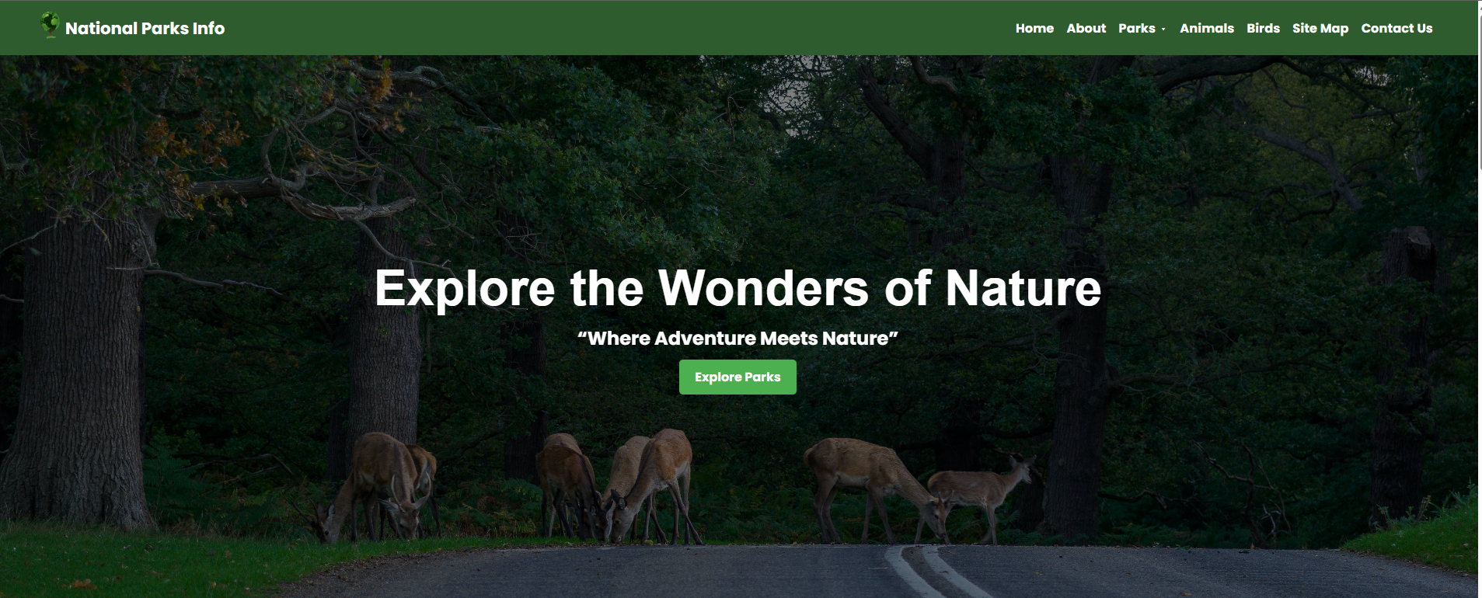

The DropDown Menu Of Parks Will Be Click On The Parks Page Then It Will Be Dropdown

